**YEAR 12 MATHEMATICS SPECIALIST SEMESTER 1 2016**

**EXTENDED PIECE OF WORK #2**

**BUT THESE AREN’T CIRCLES!!!!!!!**

Time Allowed: 55 Minutes Total Marks: 54

**1.** [4, 2, 4 marks]

Consider the equation: $\frac{{\text{x}}^{\text{2}}}{\text{4}}\text{ + }\frac{{\text{y}}^{\text{2}}}{\text{1}}\text{ = 1}$

(a) Complete the following table for the equation above. Remember that you could have TWO possible solutions for y for each value of x – one positive, one negative. (Hint: You may wish to put the equation into SOLVE.)

|  |  |  |  |  |  |  |  |  |  |
| --- | --- | --- | --- | --- | --- | --- | --- | --- | --- |
| x | -2 | -1·5 | -1 | -0·5 | 0 | 0·5 | 1 | 1·5 | 2 |
| y1 |  |  |  |  |  |  |  |  |  |
| y2 |  |  |  |  |  |  |  |  |  |

x

y

-2

-1

1

2

1

-1

(b) Sketch the graph of the equation on the axes below.

(c) (i) Between what x-values does the graph exist?

(ii) Between what y-values does the graph exist?

(iii) How do your answers to parts (i) and (ii) above relate back to the original equation?

**2.** [2, 4 marks]

Consider the equation $\frac{{\text{x}}^{\text{2}}}{\text{9}}\text{ + }\frac{{\text{y}}^{\text{2}}}{\text{4}}\text{ = 1}$

Type this equation into the MAIN screen of your calculator and then graph it from there. Set up your axes as Default.

(a) Sketch the graph of the equation on the axes below

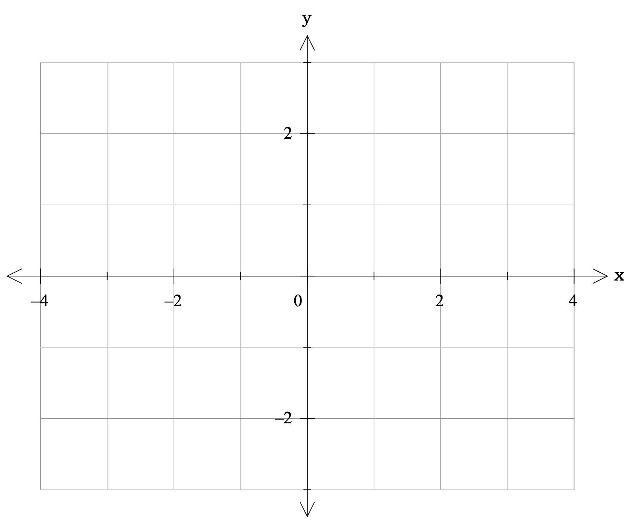(b) (i) Between what x-values does the graph exist?

(ii) Between what y-values does the graph exist?

(iii) How do your answers to parts (i) and (ii) above relate back to the original equation?

**3.** [2, 2 marks]

Consider the equation $\frac{{\text{(x} \text{-} \text{2)}}^{\text{2}}}{\text{1}}\text{ + }\frac{{\text{(y} \text{+} \text{1)}}^{\text{2}}}{\text{4}}\text{ = 1}$

(a) Sketch the graph of the equation on the axes below.

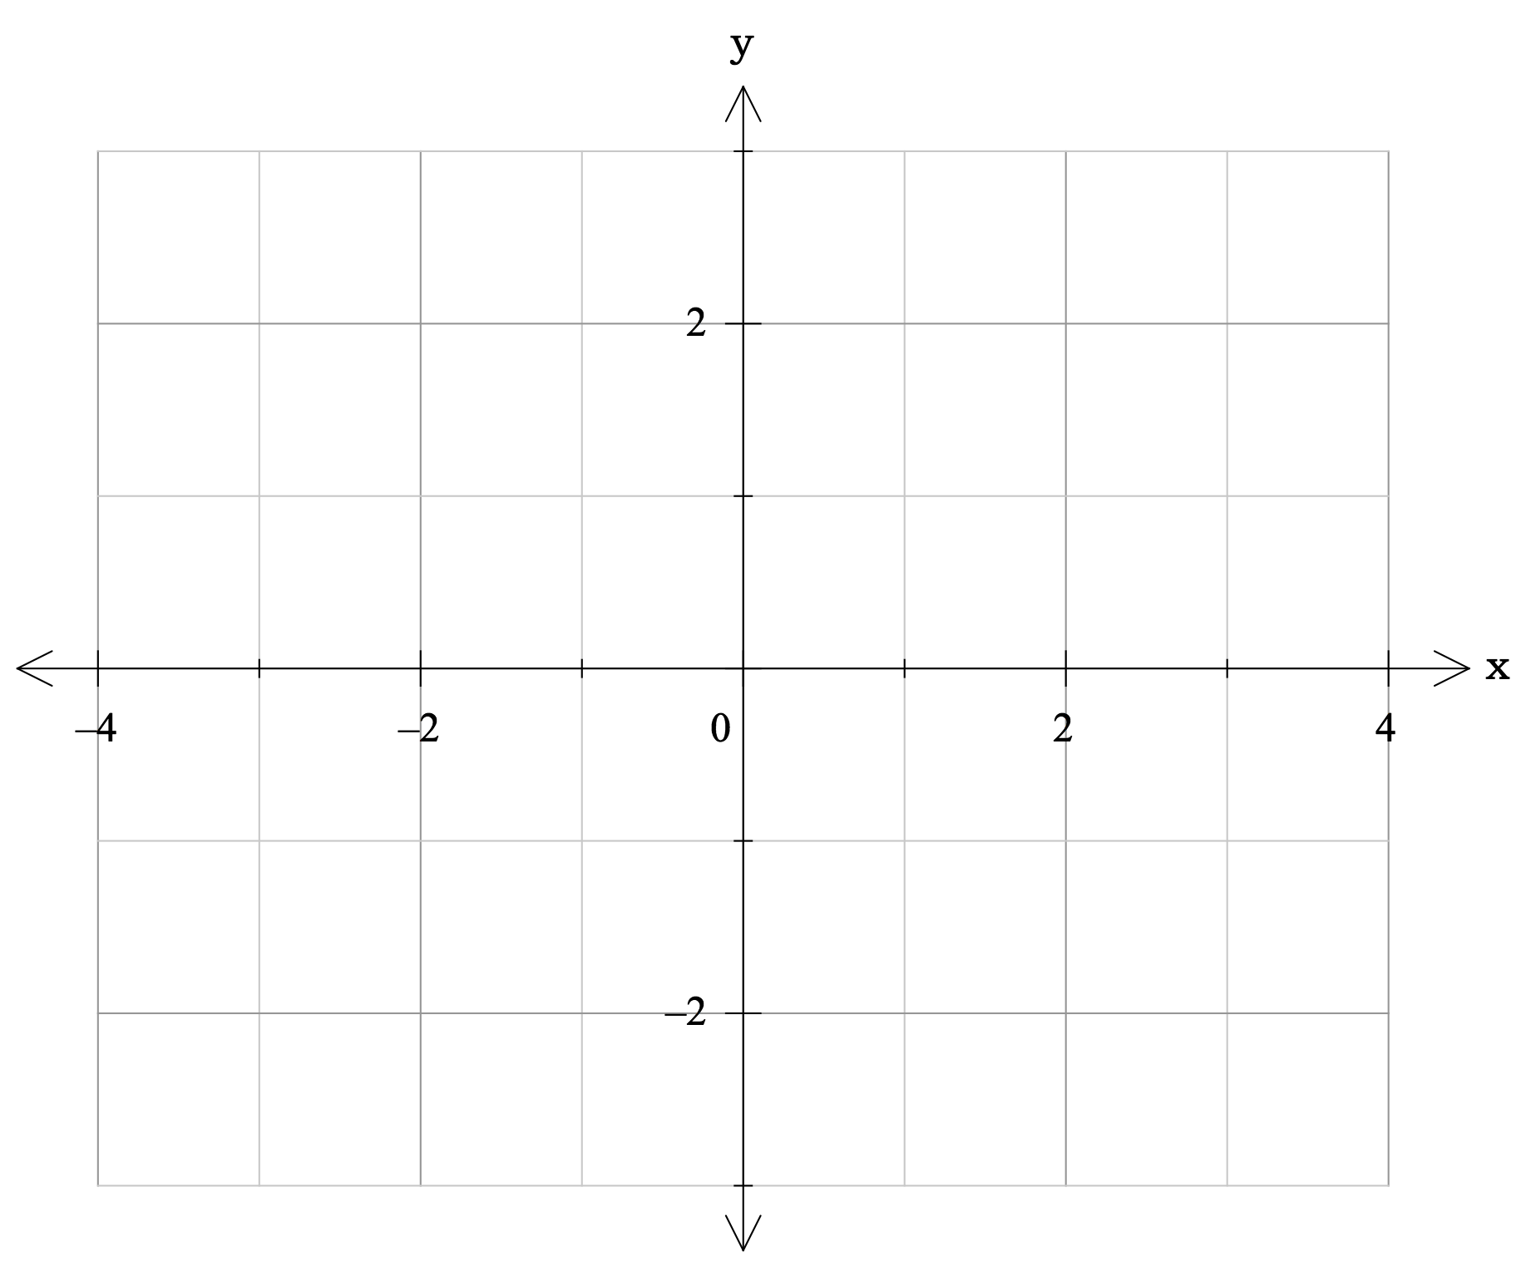

(b) *Describe* the shape and position of the graph.

**4.** [3, 4, 4 marks]

(a) Consider the equation $\frac{{\text{(x + 3)}}^{\text{2}}}{\text{16}}\text{ + }\frac{{\text{(y -} \text{2)}}^{\text{2}}}{\text{9}}\text{ = 1}$

Draw a *sketch* of the graph on the axes below, showing ALL important points (ie the points where xmax, xmin, ymax, ymin, and centre occur).

x

y

(b) Give the equation for the graph sketched below.

x

y

5

-3

(c) The general equation for an ellipse can be written in the form

$\frac{{\text{(x - d)}}^{\text{2}}}{{\text{a}}^{\text{2}}}\text{ + }\frac{{\text{(y -} \text{e)}}^{\text{2}}}{{\text{b}}^{\text{2}}}\text{ = 1}$

You may wish to draw a rough sketch of the ellipse to assist you in answering the following questions.

(i) What is the height of the ellipse?

(ii) What is the maximum x-value for the ellipse?

(iii) Give the co-ordinates for the lowest point on the ellipse.

(iv) Under what conditions would the ellipse actually be a circle?

**5.** [2, 2 marks]

A hyperbola can be graphed by the equation $\frac{{\text{x}}^{\text{2}}}{{\text{a}}^{\text{2}}} \text{-} \frac{{\text{y}}^{\text{2}}}{{\text{b}}^{\text{2}}} \text{=} \text{1}$.

Sketch an accurate graph of the hyperbola defined by:

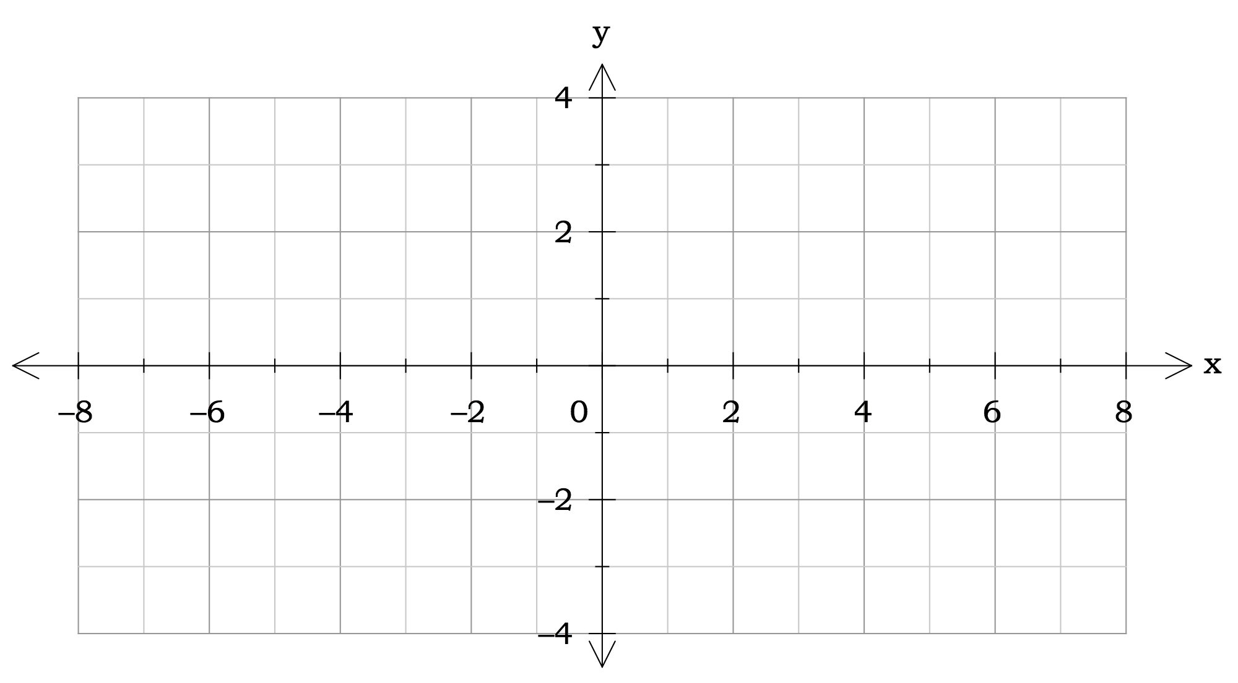(a) $\frac{{\text{x}}^{\text{2}}}{\text{9}} \text{-} \frac{{\text{y}}^{\text{2}}}{\text{4}} \text{=} \text{1}$

(b) $\frac{{\text{x}}^{\text{2}}}{\text{25}} \text{-} \frac{{\text{y}}^{\text{2}}}{\text{4}} \text{=} \text{1}$

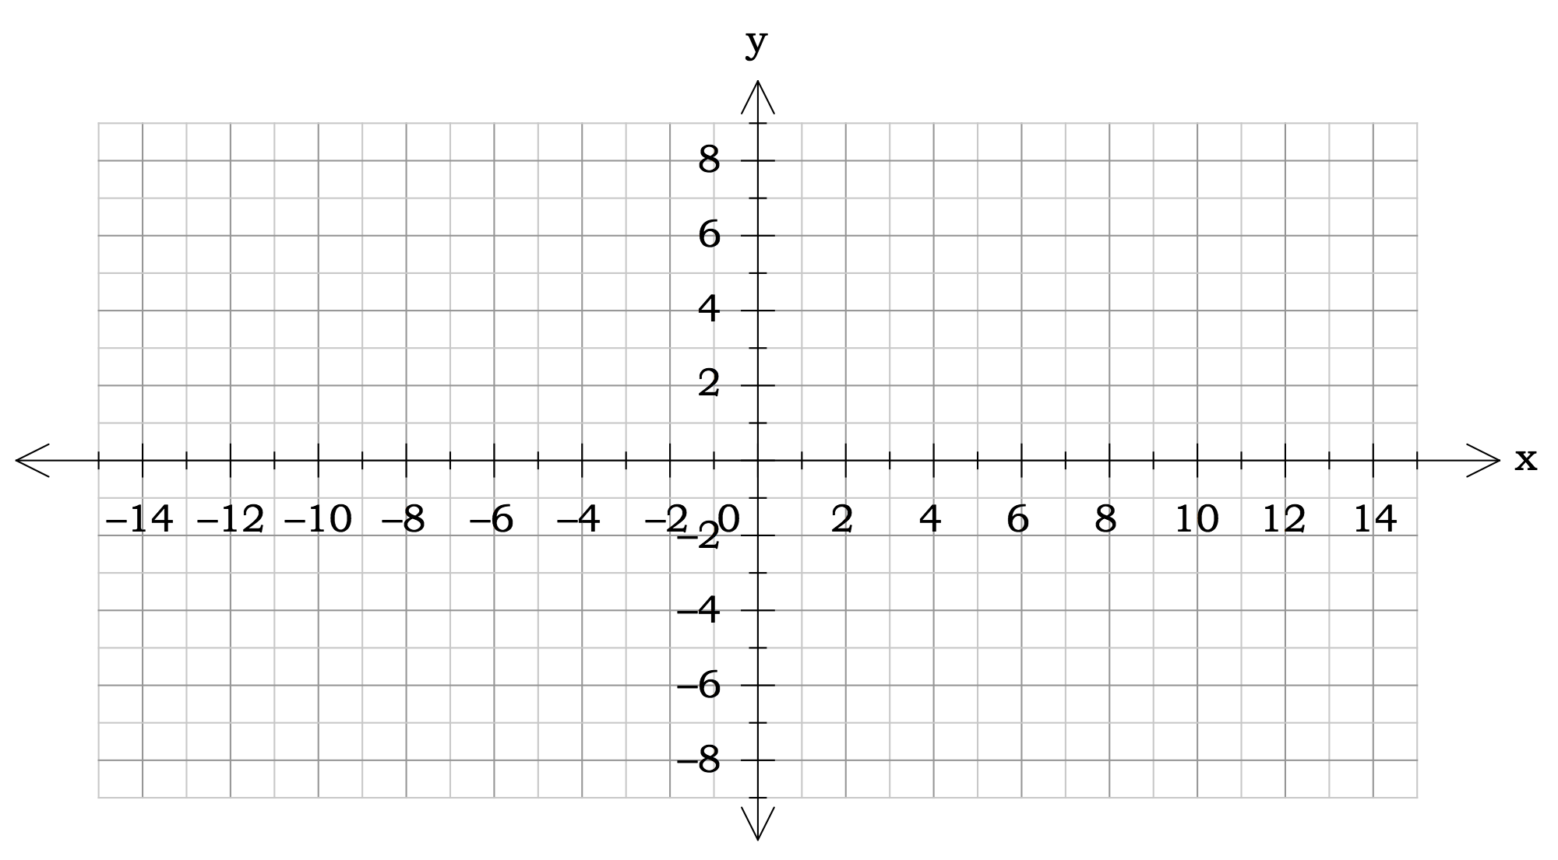

**6.** [3, 1, 1 marks]

(a) On the same set of axes, sketch the graph of $\frac{{\text{x}}^{\text{2}}}{{\text{3}}^{\text{2}}} \text{-} \frac{{\text{y}}^{\text{2}}}{{\text{b}}^{\text{2}}} \text{=} \text{1}$ for b = 2, 3 and 4.

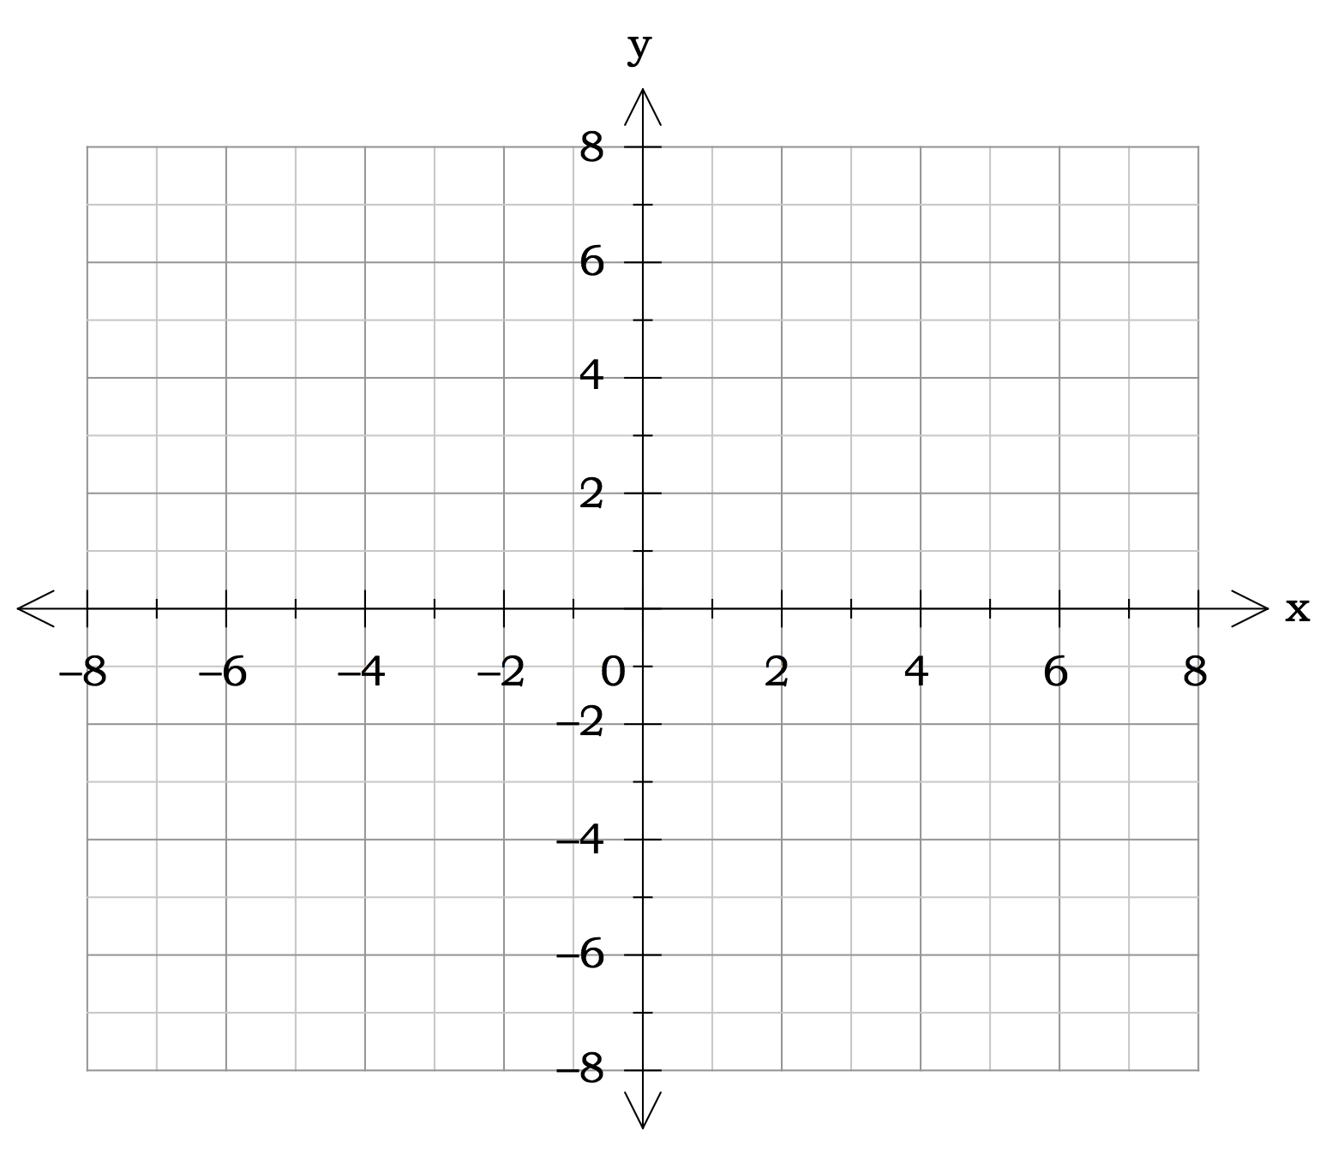

(b) Describe any changes that occurred as b changed.

(c) What did not change when b was changed?

**7.** [1, 3, 1 marks]

Hyperbolic graphs that you have studied in the past (eg $\text{y} \text{=} \frac{\text{1}}{\text{x}}$) have had asymptotes. These graphs also appear to have asymptotes.

Look at the graphs you have sketched in **5.** And **6.** above. If you were to draw in asymptotes for these graphs they would pass through a single point.

(a) What would be the point through which they pass?

(b) Rearrange the general formula $\frac{{\text{x}}^{\text{2}}}{{\text{a}}^{\text{2}}} \text{-} \frac{{\text{y}}^{\text{2}}}{{\text{b}}^{\text{2}}} \text{=} \text{1}$ to make y the subject (ie y =).

(c) By considering large values of x, determine the equations of the lines of the asymptotes for $\frac{{\text{x}}^{\text{2}}}{{\text{a}}^{\text{2}}} \text{-} \frac{{\text{y}}^{\text{2}}}{{\text{b}}^{\text{2}}} \text{=} \text{1}$.

**8.** [2, 1]

(a) Sketch the graph of $\frac{{\text{y}}^{\text{2}}}{\text{4}} \text{-} \frac{{\text{x}}^{\text{2}}}{\text{25}} \text{=} \text{1}$

(b) What are the equations for the asymptotes?

**9.** [2, 4 marks]

(a) Sketch the graph of $\frac{{\text{(x-1)}}^{\text{2}}}{\text{4}} \text{–} \frac{{\text{(y+2)}}^{\text{2}}}{\text{9}} \text{=} \text{1}$



(b) Determine the equations of the asymptotes.